DigiChars Online Game

About the Game

The point of the game is simple; be the first player to accumulate the predetermined amount of points… known as the “Point Goal”.
To accumulate points, players (represented by little circular tokens on the Game Board) move counter-clockwise around the board until they reach their starting point again (Faction Space).
The amount of spaces that each player gets to move during each of their turns is determined by a “dice roll” (which is just basically the program choosing a random number between 1 and 6).
The amount of points that each player gets when they do finally land on or pass their Faction Space is determined by how many Colony Spaces and Gold Colony Spaces they own at the time they land on or pass the Faction Space.

The Game Board

Let’s have a look at, and discuss, the Game Board image.
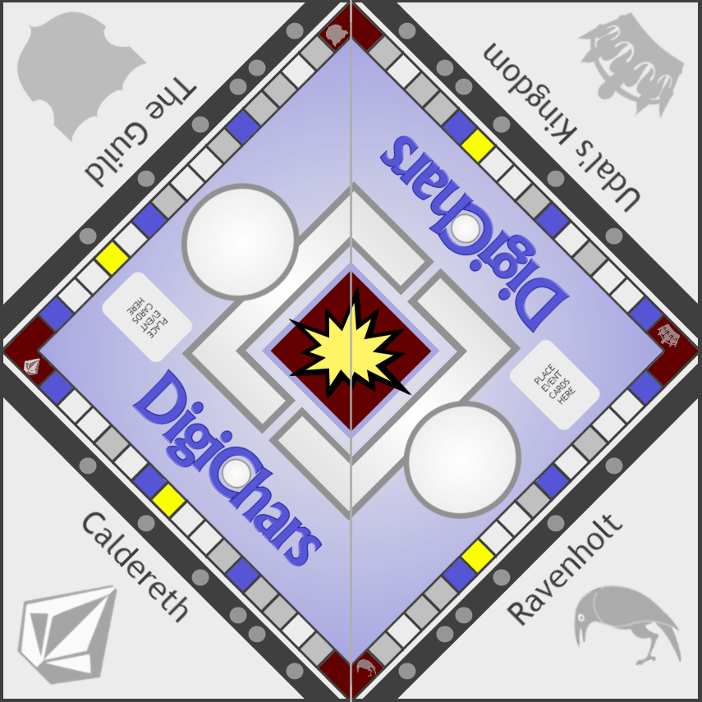
Those Red corner spaces are the Faction Spaces. The board has four (4) of them, so the maximum amount of players that can be playing the game together is four (4). The minimum amount of players that can be playing the game together is two (2). Without at least two players… well… what fun would that be?
The Blue spaces are called Event Spaces. When a player lands on one of those, it causes a randomly selected event to be triggered. These events can have either a negative or positive affect on the player or the game itself. This might include effects like doubling the amount of spaces the player moves on his or her next turn, or forcing other players to fork over a set amount of accumulated points.
Those White spaces are just Common or Standard Spaces. If a player lands on one of those spaces, nothing happens.
The Grey spaces are important. They are Colony Spaces. If a player lands on one of those, they become the owner of it! The player will see that the grey circles adjacent to the Colony Spaces they own have a black dot inside them, while those owned by other players have a red dot in them. Colony Spaces are worth one (1) point. So, if the player who owns one lands on or passes his/her Faction Space while they own it, it gives them one (1) point.
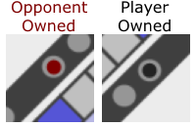
Finally, there are the Gold spaces. They are the most valuable spaces on the board. They’re called… well… Gold Colony Spaces. They function the same way as Colony Spaces, except they’re worth two (2) points, instead of one.
“What if a player lands on a Colony or Gold Colony Space that another player owns?”
Good question. The answer is… THEY BATTLE FOR IT!

Setting up the game

Let’s pretend to set up and play a game, shall we? Just to get you more familiar with how it all works.
So the player who wants to set up the game will want to determine a couple things. Foremost, they’ll want to choose which of their DigiChars they want to use.
If they’re signed in at DigiChars.com, they can click on the “DigiChars” tab in the Top Menu and scroll down to “The Game”, then click on it.
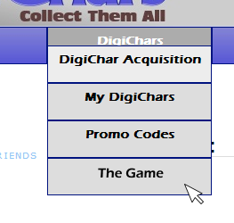
The page that next appears, we’ll call the “Game Listings” page. The player will notice the button . Also, there is a list of all the created games going on at the moment, including their “Public” or “Private” status, Point Goal amount, “Waiting” or “In Progress” status, and a button if the game has not yet started (a red “X” if the game cannot be joined).
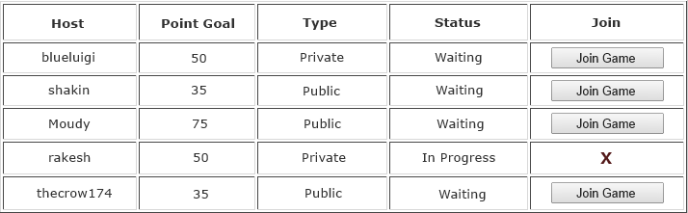
If the status of a game in this list says “Waiting”, then the player could attempt to join that game. If the status says “In Progress”, then that particular game has already started and can’t be joined. Attempting to do so simply triggers a pop up window that states “This game cannot be joined at this time.” The list “refreshes” every 2 minutes, so it’s possible to see a game that is in “Waiting” status, but when a player attempts to join, they find they cannot because the game has begun already.
But for the purposes of this little exercise, we are going to have our player create his or her own game.
So, our player clicks on the button. Now he or she will be taken to the Game Creation page and will notice they have to make a few choices.
- Public or Private: The player will want to choose whether this game is going to be “Public” or “Private”. For a “Public” game, the player has no control over who enters the game to play against him or her. In a “Private” game, the player will be prompted when another player wants to join, and the player can either “Accept” or “Deny” the other player’s request to join. The player makes their decision by clicking in either checkbox.
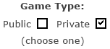

- Point Goal: The player needs to choose a “Point Goal” amount from the dropdown menu. This is the amount of points that will need to be accumulated in order to win.
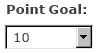

- DigiChar: The player needs to choose which DigiChar they are going to use in the game by simply clicking on the dropdown menu and selecting one of their DigiChars. The DigiChars the player owns are listed by name, and the number of “clicks” it currently has, which appears in (parentheses).
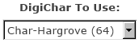

- Battle Effects: Here the player will choose the Battle Effects that can be used by their DigiChar in the game. The player chooses a maximum of three (3) Battle Effects by simply clicking on the three dropdown menus and selecting one from each list. There are three (3) categories of Battle Effects: Attack/Manipulate, Space Values, and Movement.
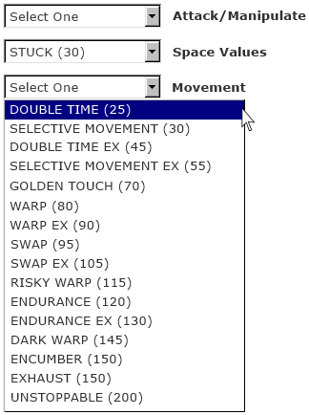

Attack/Manipulate: These Battle Effects are related to battle or manipulating the game.
Space Values: These Battle Effects are related to the point values of spaces in the game.
Movement: These Battle Effects are related to the pace or restriction of movement in the game.
These same categories apply to Event Space effects as well.

Battle Effects have a cost associated with them (shown beside the name of each Battle Effect in parentheses). This cost is paid in “clicks”.
“Paid in clicks? What the heck?”
Let’s explain this.
Part of the purpose of the www.digichars.com site is the “virtual pet” aspect of it. Users collect DigiChars and can copy/paste code for a particular DigiChar into various forum signatures, blog posts, etc.
When the DigiChar is clicked on by someone who happens to see the image that the User has posted, they effectively add one (1) additional “click” to that DigiChar’s “click total”.
It is from this “click total” that the player will now pay for his or her Battle Effects. Paying for these Battle Effects does not take anything away from the DigiChar’s “click total”, but a player can only purchase Battle Effects that they can afford based on the DigiChar’s “click total”.
For example, let’s say our player wants to buy three (3) Battle Effects for the upcoming game, and the total cost of these effects comes to 455 clicks. If the DigiChar he or she will be using has only accumulated 400 clicks so far, then the player will not be able to afford all of the chosen effects. He or she will have to either drop one of them, or choose three (3) effects that total 400 clicks or less. Get it? Got it? Good.

Anyway, the last thing here for the player to see is a link to the Battle Effects Compendium, which is just a page on the site that lists and describes what each of the Battle Effects do, how long they last, and which of the six (6) DigiChar attributes are required in order to use the Battle Effect.
“Say what?”
It’s like this. Each DigiChar has six (6) attributes, and a number between thirty (30) and one hundred and eighty (180) that represents how good the DigiChar is with each. Those attributes are:
- Leadership
- Bravery
- Strength
- Special
- Durability
- Skill
A thirty (30) would mean the DigiChar is fairly inept with regard to that attribute. One hundred and eighty (180) would mean that the DigiChar is freakin’ awesome regarding that attribute.
If a player wanted to “buy with clicks” a Battle Effect that required the DigiChar using it to have a “Leadership” attribute value of… say… ninety (90), then he or she had better make sure the DigiChar they are planning on using in the upcoming game has AT LEAST that value for “Leadership”. Otherwise, attempting to use the Battle Effect during the game will not work.

The Pre-Game

Alright. Everything is set, now our player is ready to finalize the game’s creation.
To do that, the player will simply click on the button on the “Game Creation” page.
Our player will notice that he or she can see the Game Board and the text “Waiting…” above it.
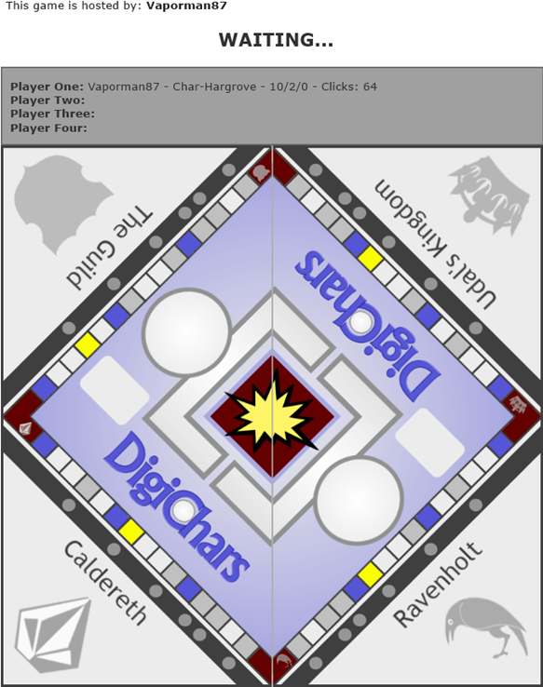
The grey area above the Game Board is showing the current players’ information, like Username, DigiChar name, the player’s Win/Loss/Quit record, and the DigiChar’s click total.
Below the Game Board, there are some buttons present. These are the buttons used for selecting a Faction to fight for. Let’s say our player is fond of Ravenholt, so he or she clicks on that one.
The button for Ravenholt darkens, and is no longer selectable by any other players. Our player can see the image of his or her DigiChar appear in the corner of the Game Board that represents the Faction chosen ; in this case Ravenholt (the lower-right corner).
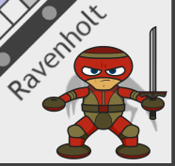
Our Player will also notice that his or her token has appeared on the Game Board, in the Ravenholt Faction Space.
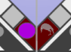
There are four colors of game tokens ; Orange, Purple, Yellow, and Green. Ravenholt’s token is Purple. Caldereth, The Guild, and Udal’s Kingdom are Orange, Yellow, and Green respectively.
Now he or she just waits for the other players to arrive. Possibly our player has already contacted some fellow DigiChar owners for a “Private” game, and is waiting for their requests to enter. These would show up as pop-up windows stating “<Username> wants to join the game.” Our player can click on or .
Or maybe our player is just hoping some random DigiChar owner looking for a game will agree to play a “Public” game. In that case, the new players will join without any prompts for our player to accept them.
In the meantime, the player will notice some other stuff below the game board.
- Chatbox: We have our Chatbox, which our player and others who join him or her will be able to use to talk to each other (NICELY!) while playing together.
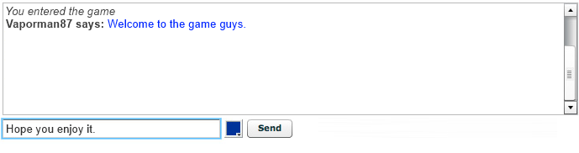
- Action Box: We have a nice little box that will display the results of any action taken by a player during the game. Each player will be able to see the results of the other players’ moves as well.
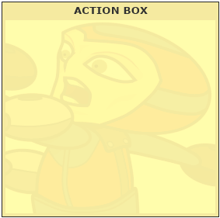

- Start Game/Pause Game Button: Only the player who created the game sees this particular button. Clicking on it either starts the game, or pauses it. However, the game can only be “Paused” a maximum of three (3) times and each time for a maximum of five (5) minutes. After five (5) minutes, the game resumes automatically.
or

- Move Roll Button: This button will be used when our player needs to “roll the dice” to determine the amount of spaces on the Game Board that they will move. It will produce a number between one (1) and six (6).

- Battle Roll Button: This button will be used when our player needs to “roll the dice” to determine whether or not a strike will be successful against an opponent in battle. It will produce a number between thirty (30) and one hundred and eighty (180).

- Attribute Roll Button: This button will be used when our player needs to “roll the dice” to determine which of the six (6) attributes of the players’ DigiChar will be used against an opponent in battle. (Don’t worry, we’ll cover battles shortly!)

- Player Points and Point Goal: Here the player can see how many points have been accumulated by each player during the game, as well as the Point Goal they are trying to reach in order to win.
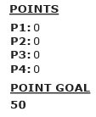

- Battle Effects Dropdown Menu and Use Battle Effect Button: This dropdown menu and its corresponding button are used prior to a battle turn. A player can choose to use one of the available effects listed here, but only if the player has taken ownership of one (1) or more Gold Colony Spaces.

You see, each time a player claims a Gold Colony Space (either through landing on it, or through battle), the amount of times that Battle Effects can be used increases by one (1). The amount of times they can be used is displayed beside the Battle Effects dropdown menu as “Available (x)”… with (x) representing the number of times left. Each time our player uses a Battle Effect, this number decreases by one (1). Also, choosing to use a Battle Effect takes the place of a normal turn in battle.
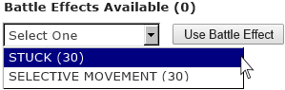

- Quit Game Button: If our player is the kind of person who likes to “disappear” when things go south, this is the button he or she will use. Seriously though, that’s just wrong. And people will know about it too, as a DigiChar’s “Quit” stat shows up prominently along with their Username/DigiChar info (as we mentioned earlier) during gameplay.

So it’s best to only use this button if absolutely necessary, and with the consent of the other players involved. Quitting the game doesn’t necessarily mean the game is over. If there are still at least two (2) players present in the game, it will continue on without our quitter. And, any spaces that our quitter had owned suddenly become NOT owned. Hurray! But if a quitter ditches the game and only one (1) poor lonely soul is left there, a pop-up box will appear telling them that “The game ended without a winner.” They click the button, and are redirected back to the Game Listings page. Thankfully, the poor player who was left behind does NOT get a QUIT added to their DigiChar’s stats like those other losers.

“What if our player accidentally closes their window, or changes pages?”
Not a big deal if our player can get back to the game page in good time. They can do this by going back in their browser, or going to the Game Listings page and clicking on the button for the game they were in (there won’t be a red “X” even though the game is in progress). But if they miss three (3) turns in a row, they’ll be kicked from the game, and unable to get back in.
“Okay, what if everyone leaves the game page to go watch cartoons on YouTube?”
See, there is a time limit for a player’s turn. It is five (5) minutes.
So, if a player doesn’t click their Move Roll or Battle Roll buttons as required for EVERY turn (unless a Battle Effect or Event Space forced a player’s turn to be skipped or manipulated) within five (5) minutes, they lose their move or battle turn.
If they lose any combination of move and battle turns three (3) times in a row because of this time limit being reached, then they are booted from the game and given a big, fat QUIT to their DigiChar’s stats. So, to answer your question, those YouTube junkies will find their game disappeared from the list after they finished watching those “Dancing With The Stars” clips.

Here we go!

Let’s say our player and a couple of his friends are ready to go now.
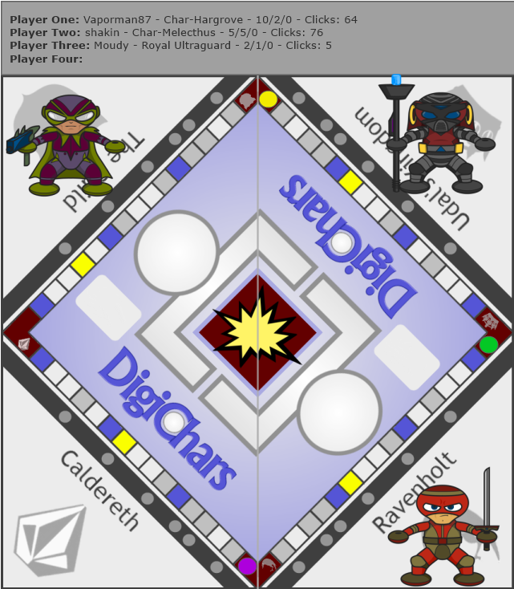
Our player is satisfied with the group he or she is playing with, so now they are going to click on the button, and away we go.
Our player, the game’s creator, gets to go first! He’ll be followed by the person who first joined him, and then the second person who joined. So the order of turns is based on when they joined the game.
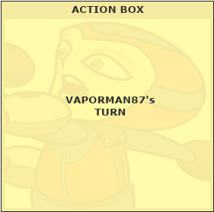
ROUND 1
Our player clicks on the button (the other buttons do nothing until they are needed for use in a turn). In his or her Action Box, there appears a nice little picture of dice and a number between one (1) and six (6). Let’s say it was a three (3).
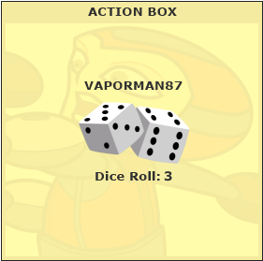
Now our player will see his or her game token move from their Faction Space (which we said was Ravenholt), counter-clockwise, three (3) spaces.
Oh goody! Our player has landed on one of the grey Colony Spaces! That means that our player now OWNS that space. He or she will see a black dot appear within the little grey circle next to this Colony Space. But to the other two (2) players, the dot will appear red (indicating that an opposing player owns the space).
Our player’s Action Box tells us the good news.
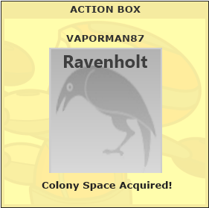
The next player will now commence his turn. He will perform the same actions that our player could have or did.
Also, our player can see the results of his opponents’ actions/selections in his or her Action Box.
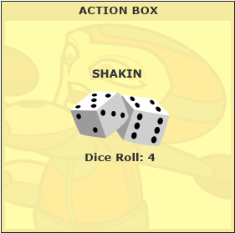
Our player sees that this next player has rolled a 4, and is moving four (4) spaces. They too have landed on, and therefore acquired, a Colony Space. Boo!
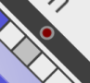
Our player will notice that all of the buttons and dropdown menus are useless while it is NOT his or her turn. Well, with the exception of the button (which was previously the button prior to our player starting the game) and the button (which our WAY too cool player will NOT be using).
ROUND 2
After the third player takes his turn, our player is once again ready to take theirs.
Let’s say a click on the button produces a dice roll of two (2).
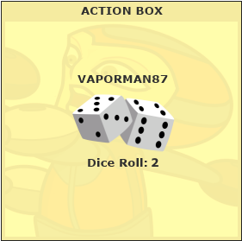
So he or she watches as the Ravenholt token moves two (2) spaces counter-clockwise.
Oh boy. Our player has landed on one of the blue Event Spaces. Sometimes these are beneficial, but mostly they are not.
Within the Action Box, our player can read the result of landing on this space.
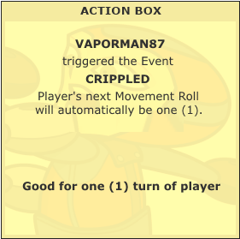
Well, that isn’t too bad. It could have been worse. Wait a minute! That means our player’s next roll is going to put him or her on a Gold Colony Space! YES!
Our player’s turn is over, and now the others are taking their turns.
It looks like the third player has also landed on a blue Event Space. Stinks to be him. Or… does it?
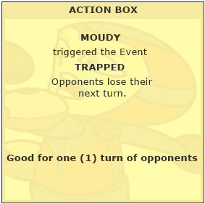
That’s bad. Now our player and the second player have to wait and watch as the third player gets to go again.
ROUND 3
With the third player completing his second turn in a row, it is finally our player’s turn again.
Clicking on the button produces the one (1) roll that was promised by landing on that Event Space last time our player rolled.
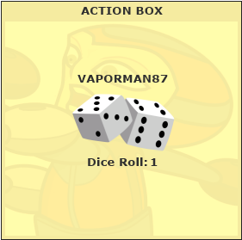
That means he or she is on that Gold Colony Space, and now owns it!
As was mentioned, these rare Gold Colony Spaces are worth two (2) points when our player lands on or passes the Ravenholt Faction Space!
Things are looking good for our player so far.
>>> FAST FORWARDING A BIT…
ROUND 7
Now at Round 7, our player owns eight (8) Colony Spaces and one (1) Gold Colony Space. Things are really going swimmingly at the moment.
Our player clicks the button, and the Action Box shows that he or she has rolled a two (2).
This puts our player’s token squarely on a Colony Space owned by the second player. That means it’s time to do BATTLE!

Our player was the one who landed on the owned Colony Space. This makes him or her the “Attacker”. The current space owner, the second player, is the “Defender”. The “Attacker” always gets to go first during battle.
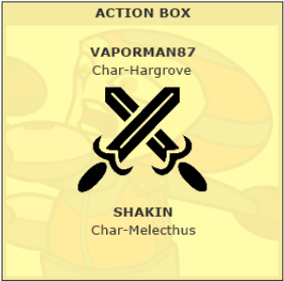
Having landed on this owned Colony Space, our player can see in the Action Box a nice little weapon image and the Usernames and DigiChar names of the battle participants. Our player can do a couple of things here. He or she can:
- Begin the normal battle procedure
or
- Select a Battle Effect
Our player can use a Battle Effect if they choose to, because they acquired a Gold Colony Space earlier in Round 3.
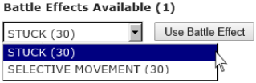
Even if, during the course of the game leading up to this round, our player had lost ownership of that Gold Colony Space to another player, our player would STILL have the one (1) available opportunity he or she gained to use a Battle Effect. The only way that a player loses an available opportunity to use a Battle Effect, is by actually using it.
In this case however, our player has chosen not to use a Battle Effect.
To begin normal battle procedure, our player must first click on the button. The beautiful dice image will appear in the Action Box, and a number between one (1) and six (6) appears with it. Let’s say our player has rolled a four (4).
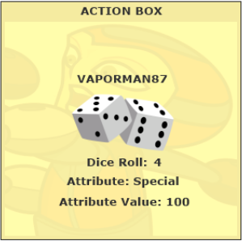
Attribute number four (4) is the Special attribute, and the remainder of this battle will be fought using this attribute.
Our player’s DigiChar has a Special attribute value of one hundred (100).
“So… uh, why does that matter?”
Well, it means that our player’s Battle Rolls during this battle have to equal 100 or less in order for him or her to successfully “strike” the opponent. Battle Roll amounts can be any number between thirty (30) and one hundred and eighty (180)… just like the values of a DigiChar attribute.
“Ooh… I get it. But what’s a “strike”?
It takes three (3) strikes against your opponent to be victorious. So if our player gets three (3) Battle Rolls of one hundred (100) or less in this battle, he or she is the winner of the battle!
“Oh… oookay. So the first player to get those three (3) strikes is the winner.”
Correct. You’re catching on pretty quickly here Mr. Disembodied Question Man.
“I’m no dummy. Well… unless you ask my wife.”
Anywaaayyysss…
Okay, so… now that our player has determined which DigiChar attribute will be used for this battle, his or her next move is to click on the button. Once again, our player can see in the Action Box that our extremely gorgeous, highly detailed pic of dice has appeared and the number our player has rolled is… we’ll say… seventy eight (78).
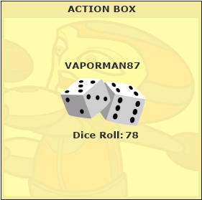
Seventy Eight (78) is less than the one hundred (100) attribute value. STRIKE ONE against our player’s opponent! Soon, the Action Box changes to declare the good news.
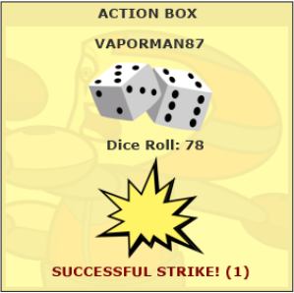
The phrase “SUCCESSFUL STRIKE!” followed by the amount of “strikes” accumulated by our player so far (in parentheses) in this battle appears below our dice image.
Now it’s in the hands of the opponent. Our player’s opponent will go through all the same choices and button clicks as our player. Our player can see all of this via the Action Box. He or she sees that the opponent had an Attribute Roll that selected his DIgiChar’s Leadership attribute, that his Battle Roll ended up being equal to or less than his DigiChar’s Leadership attribute value, and that our player took a “strike” in return.
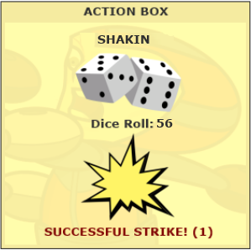
STRIKE ONE on our player. Darn.
The Battle Rolls continue back and forth… some resulting in “strikes” some in “misses”.
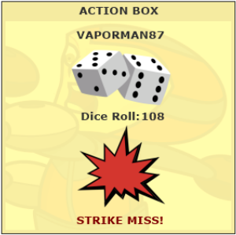
But now there are two (2) “strikes” against each of them, and it’s our player’s turn. A swift click of the button and the Action Box shows a roll of forty (40)!
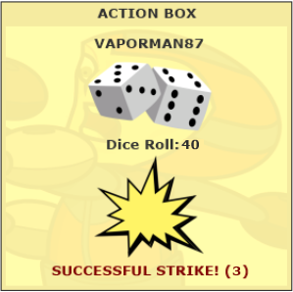
STRIKE THREE against our player’s opponent! Victory! Soon, the Action Box changes to announce the winner and that he or she has acquired the Colony Space!
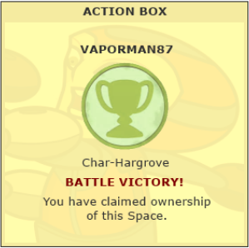
The red dot that was in the grey circle next to the Colony Space that our player’s opponent USED to own, now turns black, and our player has taken ownership of that Colony Space!
The next turn goes to the second player in the same order as before.

Just a bit more

Hopefully that little play through gave you some insight into the mechanics of the game.
Though, there are still some things you should know about.
“Yeah… like what if our player HAD decided to use a Battle Effect to start the battle with that evil, nasty second player?”
Wow that’s… that’s exactly what I was going to say.
“I know.”
BATTLE EFFECTS
But… uh… yeah, so what if our player HAD made that choice? Well, keep in mind that just because they are called “Battle Effects” doesn’t mean that the effects are limited to the battle. Some of these effects work like Event Spaces, in that they can affect some aspect of the game as a whole.
But, whatever the effect may be, selecting a Battle Effect basically acts as a turn in itself. Once one is selected by clicking on the button, the effect is applied, and that player’s turn in battle ends. In the Action Box, the player will see text that shows the name of the Battle Effect and the effect that it will have.
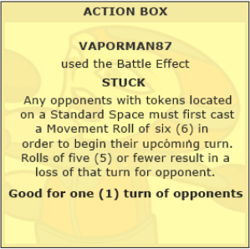
“Cool.”
Yes. Yes it is.
POINTS
Also, as was stated much earlier, the point of the game is to rack up… well, points. To do that, the player must land on or pass their Faction Space. The total amount of Colony Spaces and Gold Colony Spaces that the player owns is then calculated and the proper point amount is given to the player (one (1) point for Colony Spaces, two(2) for Gold Colony Spaces).
In our play through, we would say that our player, having passed or landed on his or her Faction Space, earned eleven (11) points toward their total thus far. If the Point Goal for the game was fifty (50), then our player would still have a ways to go before winning.
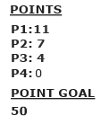
WINNING
Oh yeah, about winning…
Once a player of the game lands on or passes their Faction Space and has accumulated an amount equal to or greater than the Point Goal, the game is over.
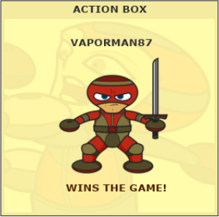
A pop up window will appear to all players telling them the game is over and clicking on the button in this pop up will close the game screen.
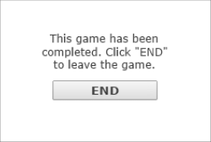
Also, when a winner is determined, the game disappears from the Game Listings page on the next refresh.
The winner’s DigiChar will earn one (1) “Win” in their “Win/Loss/Quit” stats (Losses for the losers, naturally).
Also, the amount of “Battle Wins” and “Battle Losses” that took place in the game for each player is added to those statistics for the DigiChars they used in the game.

Well, that about wraps things up here. Now get playing the game!
“How do you play again?”
Oh boy.

